* Purpose : Classwork.
* Date : 30/12/2025
* Author : Vikas Srivastava
* ID : 55984
* Batch ID : 25SUB4505

- Code : Write a program to demonstrate the order of execution of constructors and destructors in multiple inheritance in C++, showing that base class constructors are called first (in inheritance order), followed by the derived class constructor, and destructors are called in the reverse order when the object goes out of scope.
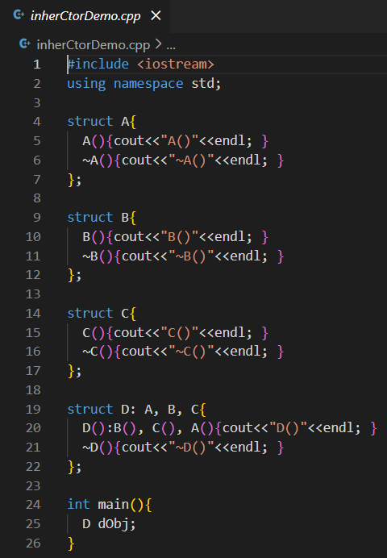
Output :
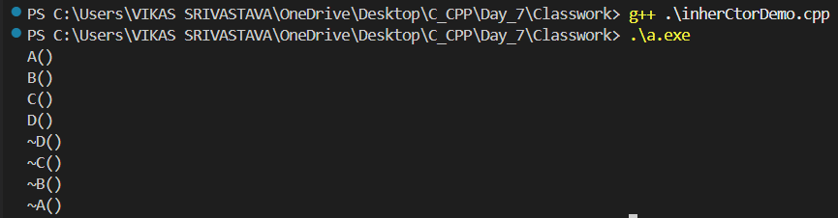

- Code : Write a program to demonstrate the order of constructor and destructor execution in single inheritance in C++, where the base class constructor executes first, followed by the derived class constructor, and destructors are called in reverse order when the object goes out of scope.
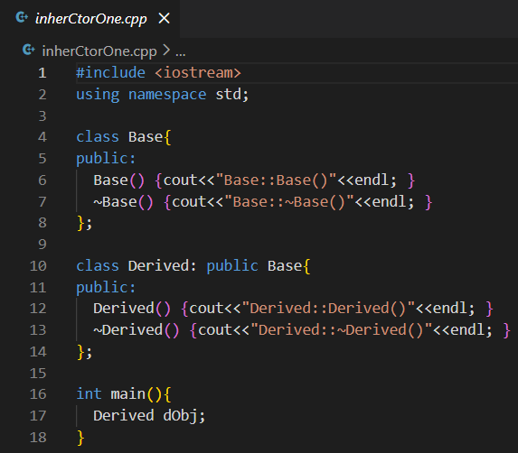
Output :
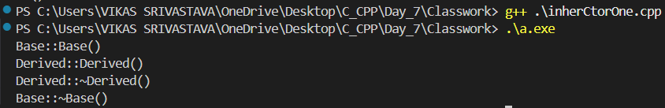

- Code : Write a program to demonstrate constructor chaining in C++ inheritance, where a derived class constructor explicitly calls a parameterized base class constructor using an initializer list, and observe the order of constructor and destructor execution.
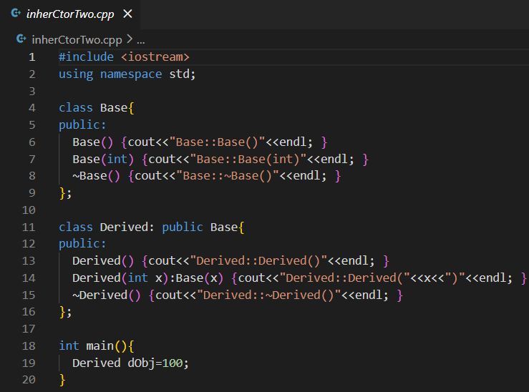
Output :
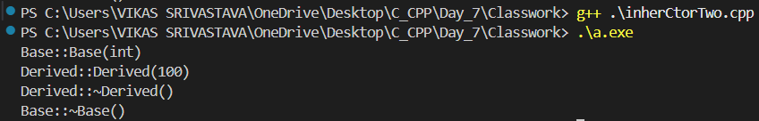

- Code : Write a program to demonstrate multilevel inheritance in C++, where a class is derived from another derived class, allowing the grandchild class to access the member functions of both its parent and grandparent classes, showcasing hierarchical access in object-oriented programming.
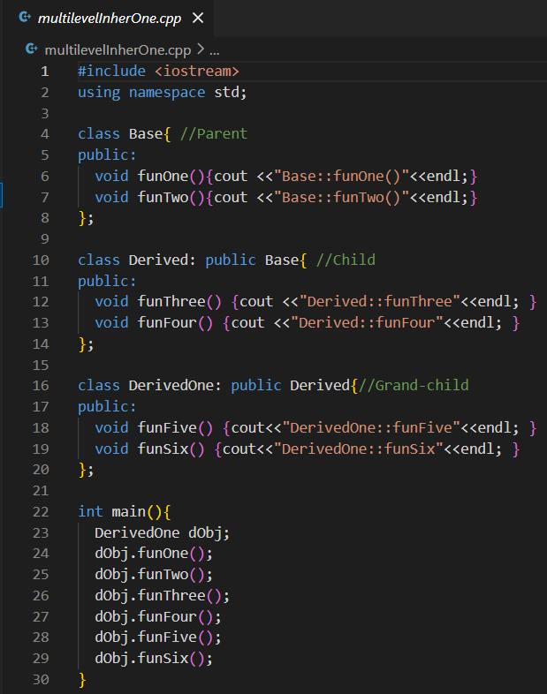
Output :
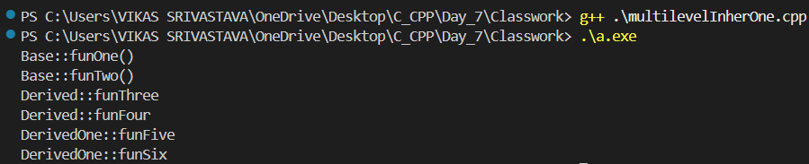

- Code : Write a program to demonstrate multiple inheritance in C++, where a derived class inherits from two different base classes, allowing the derived object to access member functions of both base classes along with its own functions.
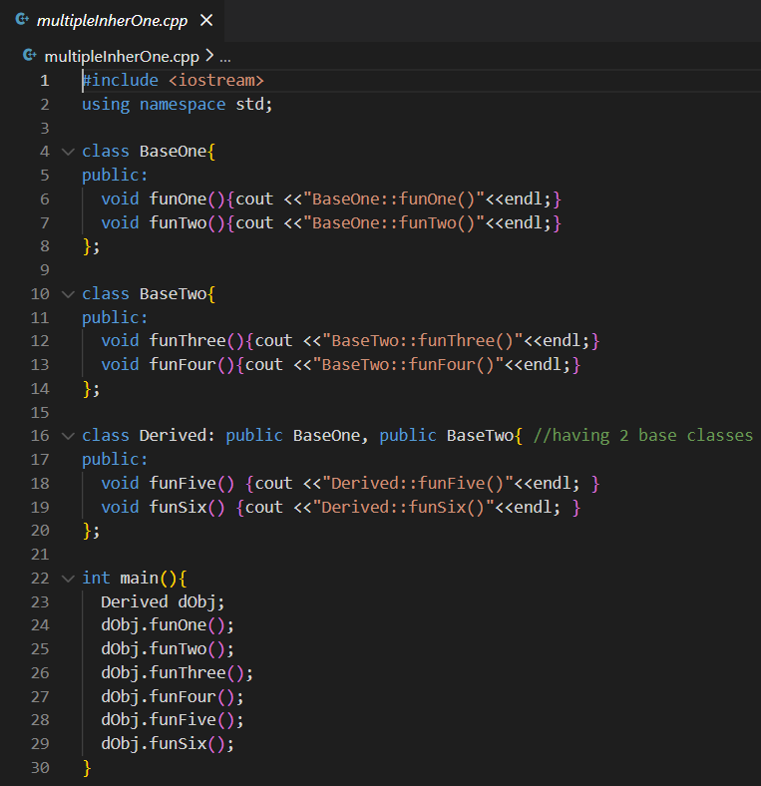
Output :
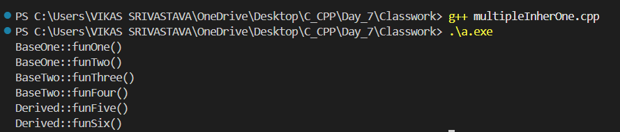

- Code : Write a program to demonstrate how function name ambiguity in multiple inheritance can be resolved using the using declaration, allowing specific base class functions to be directly accessible in the derived class.
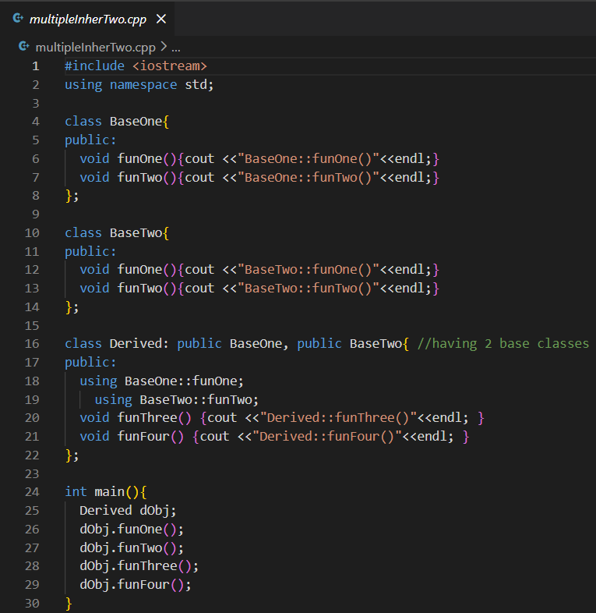
Output :
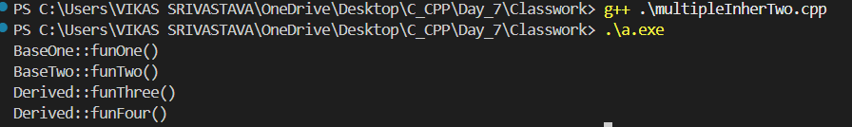

- Code : Write a program to demonstrate operator overloading in C++, where arithmetic operators (+ and -) are overloaded using friend functions to perform operations on objects of a user-defined class, along with overloading the stream insertion (<<) operator to display object data.
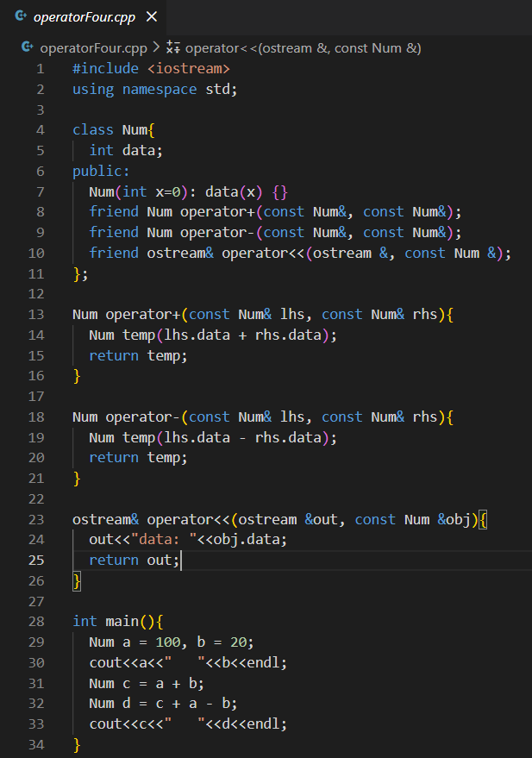
Output :
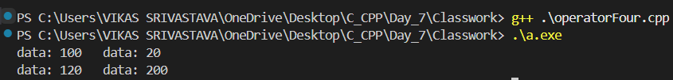

- Code : Write a program to demonstrate overloading of global new and delete operators in C++, showing how memory allocation and deallocation can be customized globally, and how object construction and destruction occur alongside these custom memory management functions.
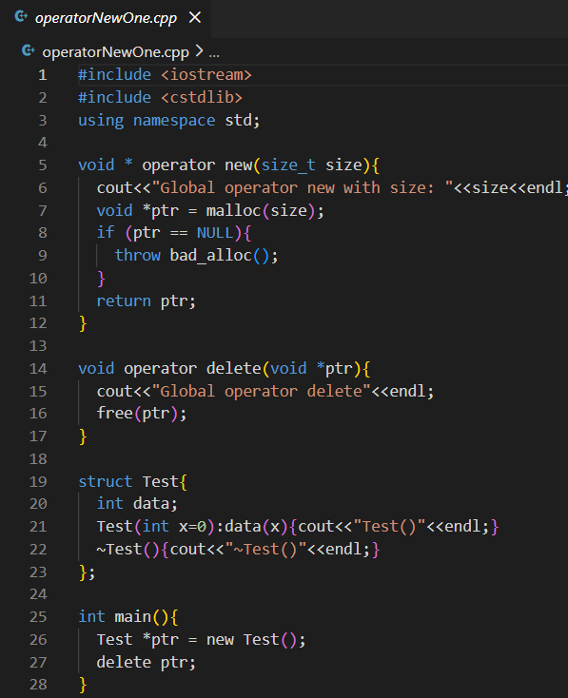
Output :
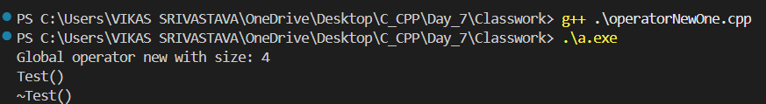

- Code : Write a program to demonstrate overloading new and delete operators at the class level in C++, allowing a class to control its own memory allocation and deallocation, separate from the global new and delete operators.
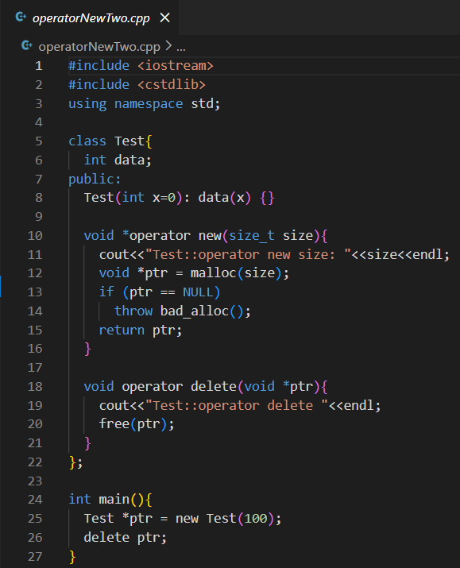
Output :
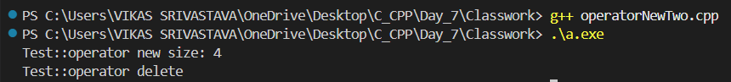

- Code : Write a program to demonstrate operator overloading for pre-increment (++a) and post-increment (a++) in C++, showing the difference in behaviour and return values when these operators are applied to objects of a user-defined class.
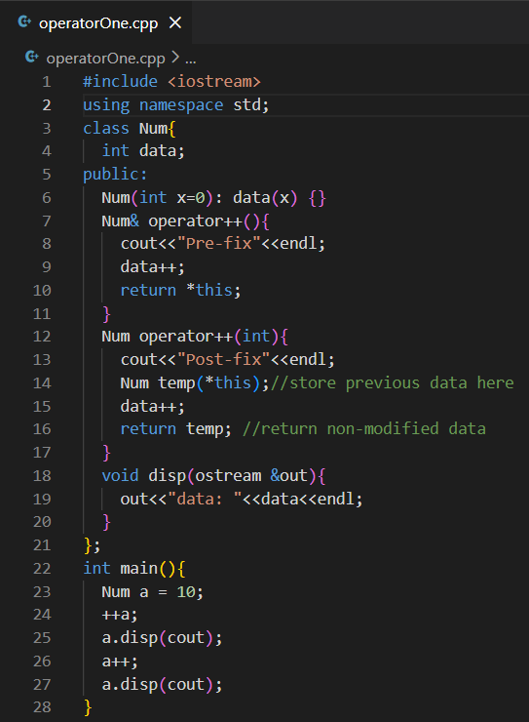
Output :
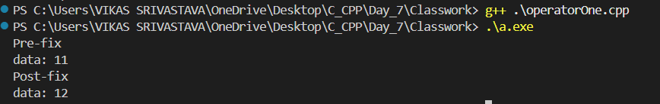

- Code : Write a program to demonstrate operator overloading using member functions in C++, where arithmetic operators (+ and -) are overloaded inside a class to perform operations on objects, and the stream insertion operator (<<) is overloaded to display object data.
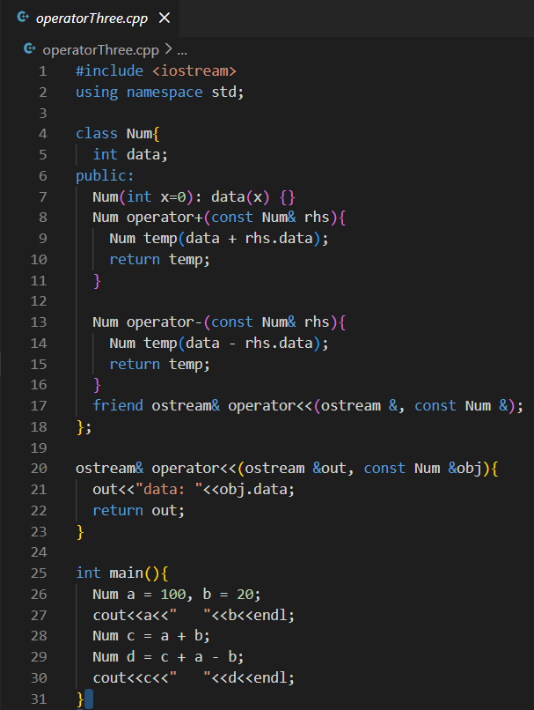
Output :

- Code : Write a program to demonstrate operator overloading using member functions in C++, where arithmetic operators (+ and -) are overloaded to operate on objects of a class, and a separate display function is used to print object data instead of overloading the stream insertion operator.
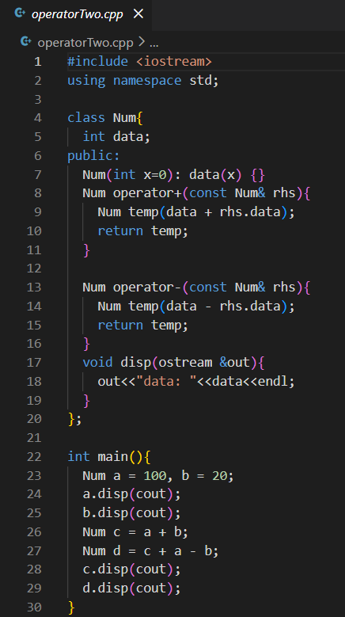
Output :
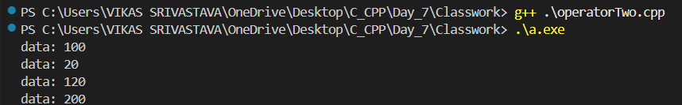

- Code : Write a program to demonstrate runtime polymorphism in C++ using a virtual function, where a base class pointer calls the appropriate overridden function based on whether it points to a base class object or a derived class object at runtime.
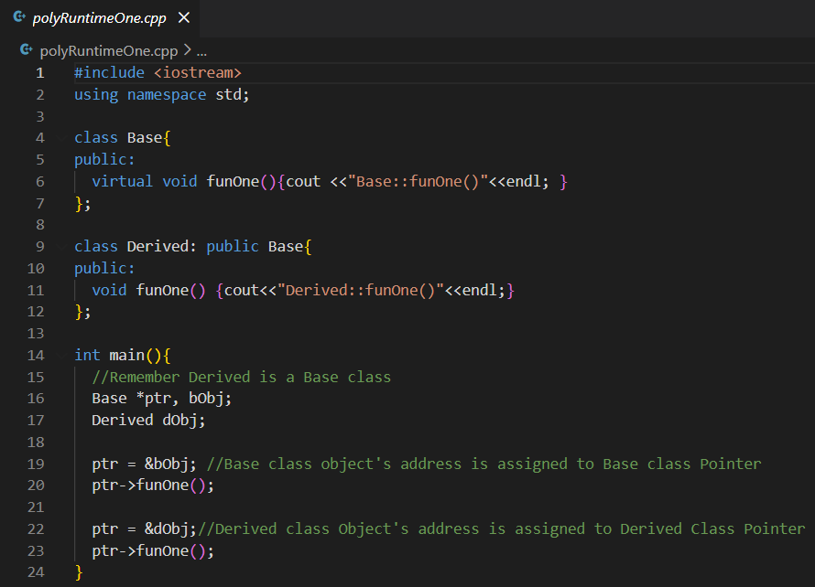
Output :
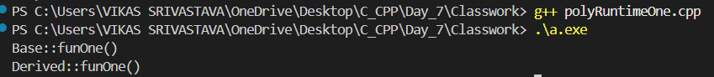

- Code : Write a program to demonstrate access specifiers in C++ (private, protected, and public) and how they behave during inheritance, showing that private members are not accessible, protected members are accessible within derived classes, and public members are accessible everywhere through derived class objects.
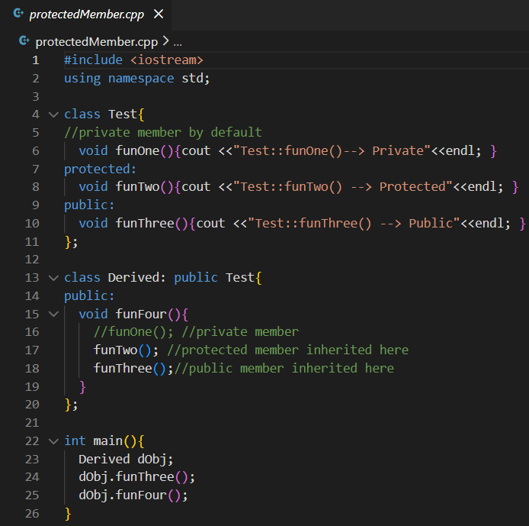
Output :
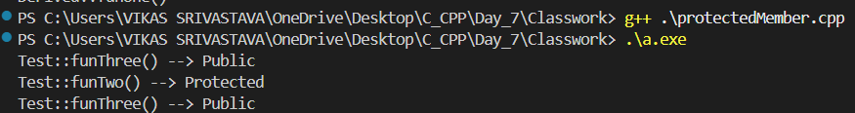

- Code : Write a program to demonstrate single inheritance in C++, where a derived class inherits public member functions from a base class and can access both the inherited functions and its own member functions using a derived class object.
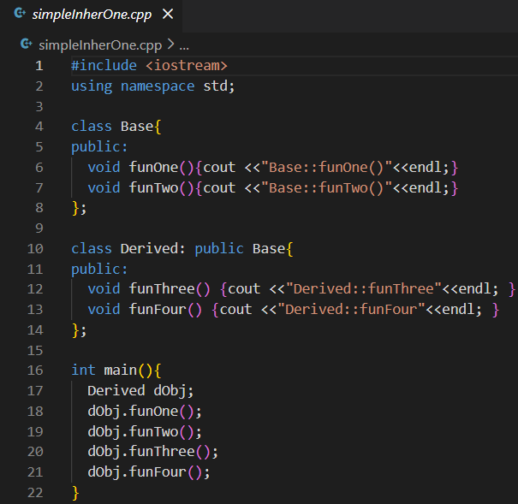
Output :
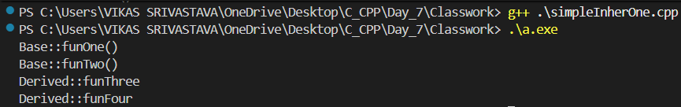

- Code : Write a program to demonstrate string tokenization in C using the strtok() function, where a sentence is split into individual words based on a delimiter (space) and each token is printed separately.
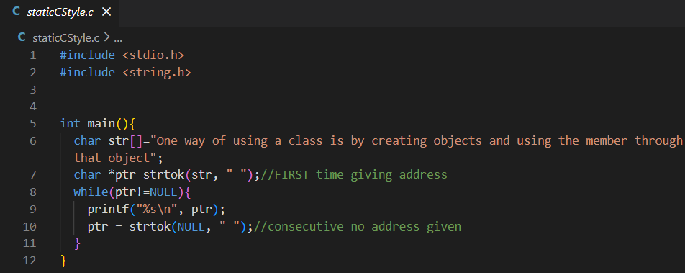
Output :
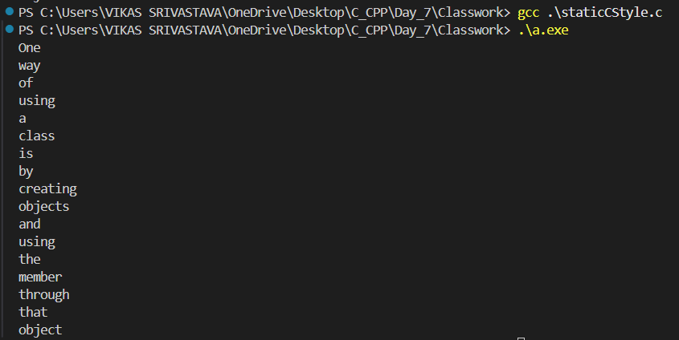

- Code : Write a program to demonstrate string tokenization in C++ using the strtok() function from the C string library, where a sentence is split into words based on a space delimiter and each token is printed on a new line.
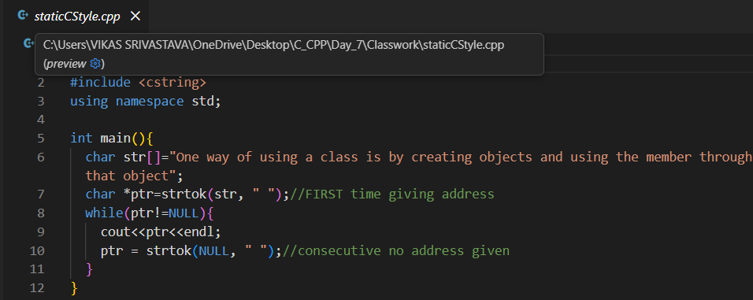
Output :
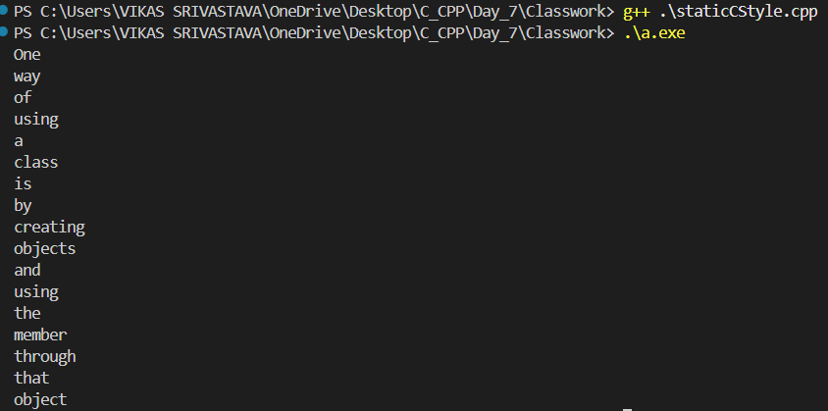

- Code : Write a program to demonstrate the use of a static local variable inside a function, where the variable retains its value between multiple function calls and continues incrementing instead of being reinitialized each time.
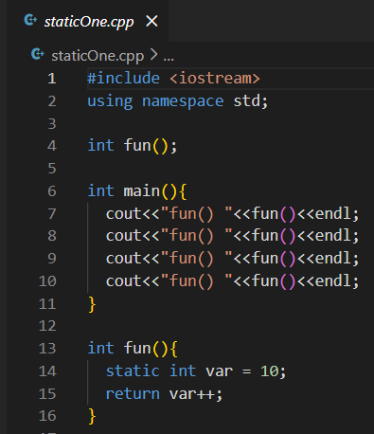
Output :
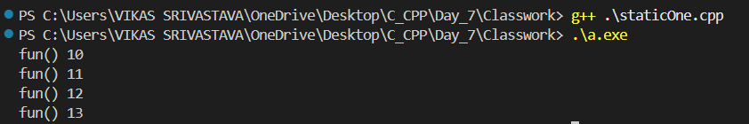

- Code : Write a program to demonstrate method chaining in C++ by returning *this from a member function, allowing multiple member function calls to be chained together on the same object using the this pointer.
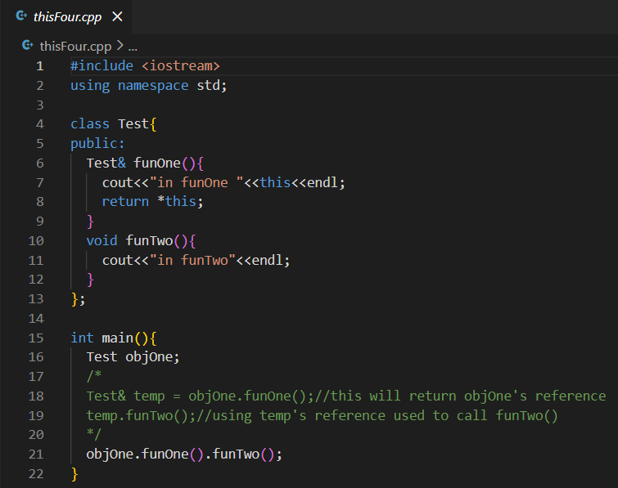
Output :
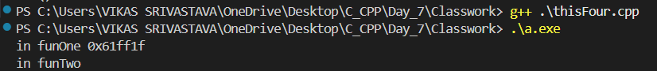

- Code : Write a program to demonstrate the use of the this pointer in C++, showing that it holds the address of the calling object, allowing the same member function to distinguish between different object instances at runtime.
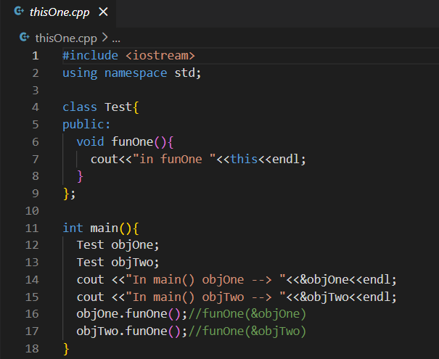
Output :
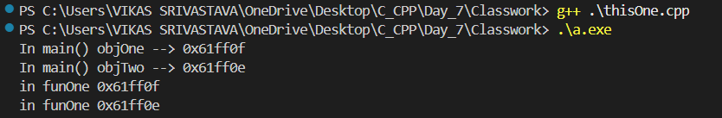

- Code : Write a program to demonstrate how the this pointer is used in C++ to differentiate between a class data member and a function parameter with the same name, ensuring the correct assignment to the object’s data member.
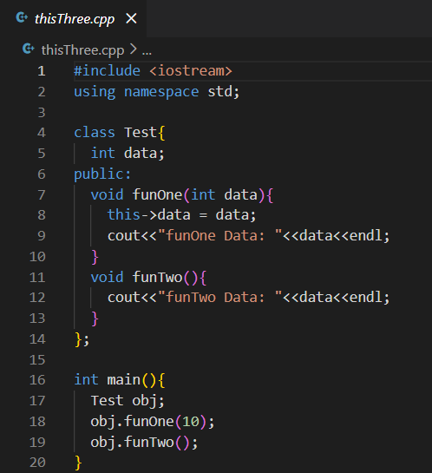
Output :
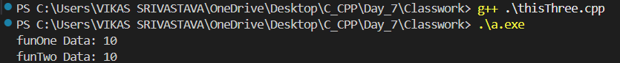

- Code : Write a program to demonstrate how the this pointer refers to the address of the current object, showing that the same member function prints different addresses when invoked by different objects.
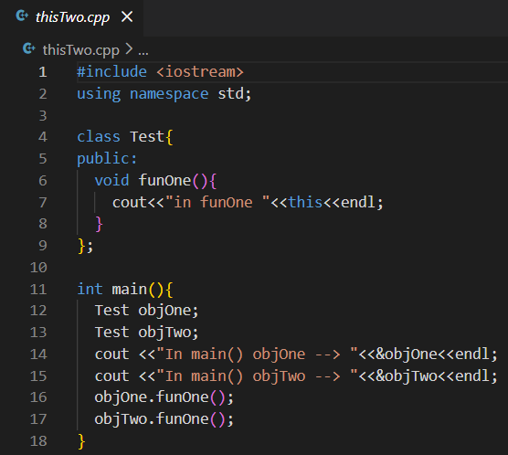
Output :
